University of Utah
School of Computing
CS 6967: Security Operations

Name: Syeda Mishra Saiara
uID: u1457424

Lab 13 Response Outline

Lab 13: Threat Hunting with Disk Data
Test 1: Capture a Disk Dump
Summary of test experience:
The goal of this experience is to capture the disk dump from the windows machine. For doing so, at first a tool for dumping disk data, FTK imager, is downloaded. For dumping the disk, or making the image of the disk at first a new disk was created in the windows VM. The new disk was configured with the image provided in the manual. After creating the disk memory in the windows VM, using FTK Imager, the copy of the created disk was created as a dump. Finally it gave the information of the disk imaged for verification.
Screenshot of test results:
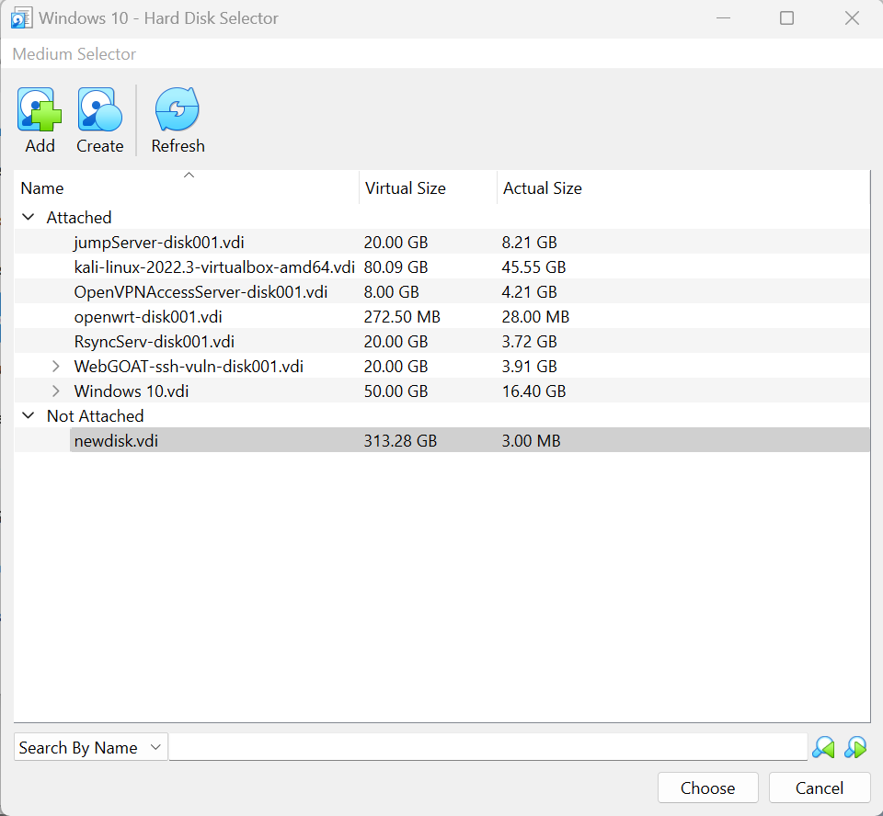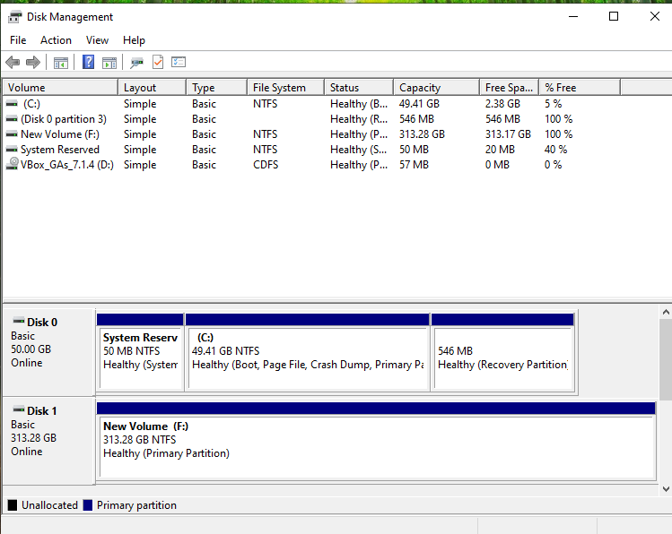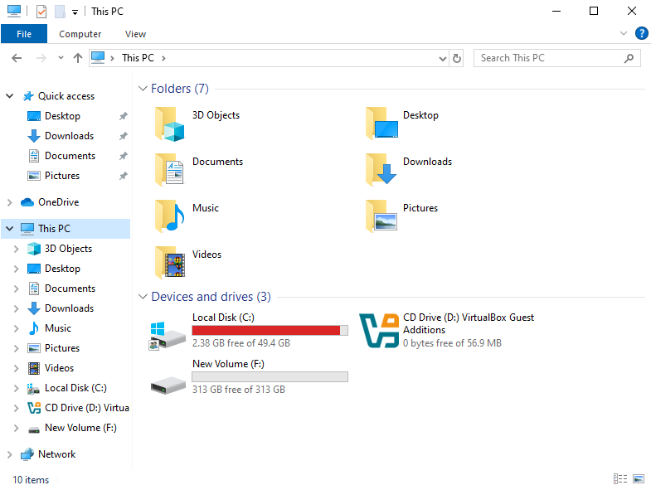
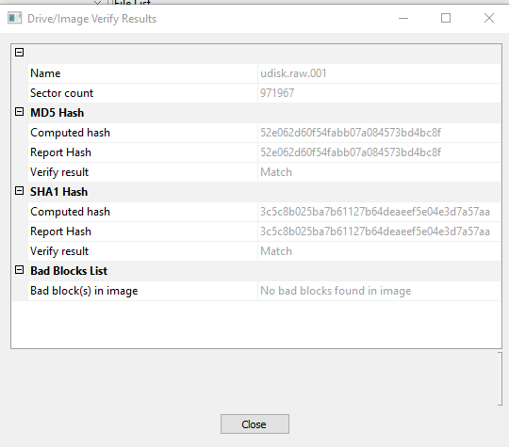
How does the image demonstrate that you completed the test?
The last image shows that the SHA and MD5 hash matches with the disk that is created and copied through FTK imager.

Test 2: Load the Disk Dump Into Autopsy
Summary of test experience:
The second part of the experiment is to do a disk forensics with autopsy. I did the whole thing in windows and not in Kali. I installed Autopsy in windows. Then downloaded the window image provided. After that, the downloaded image was loaded in Autopsy. After completion of the part, the downloaded disk information was loaded in Autopsy.
Screenshot of test results:
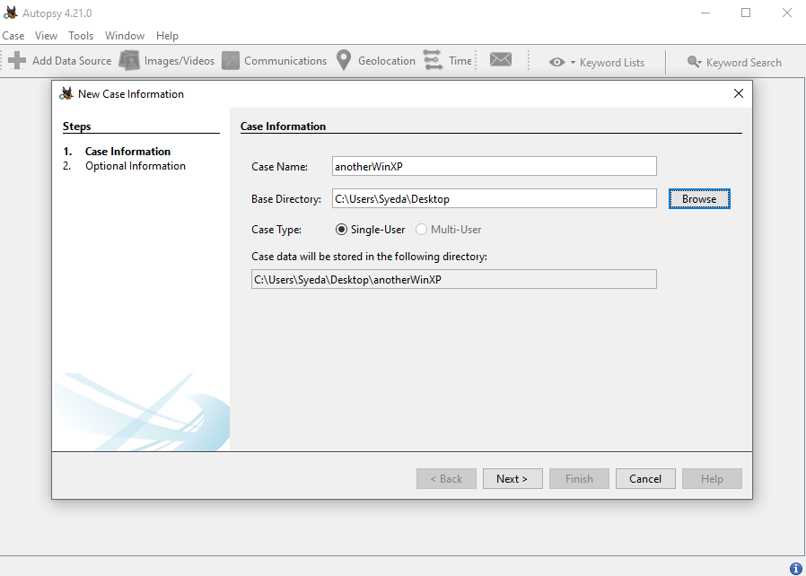
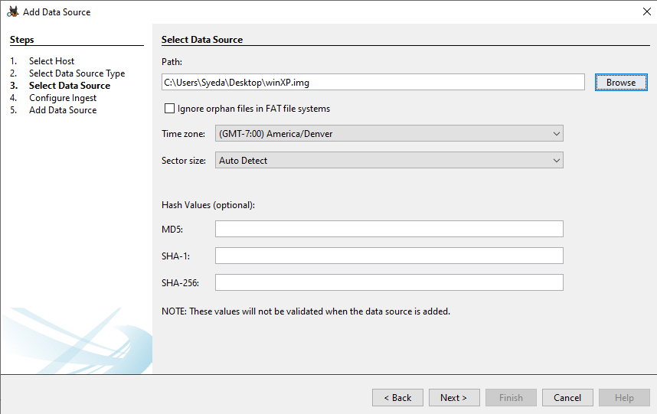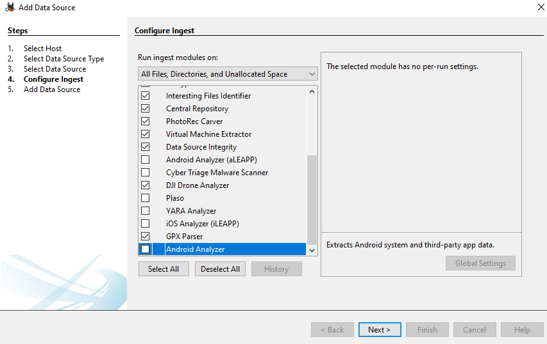
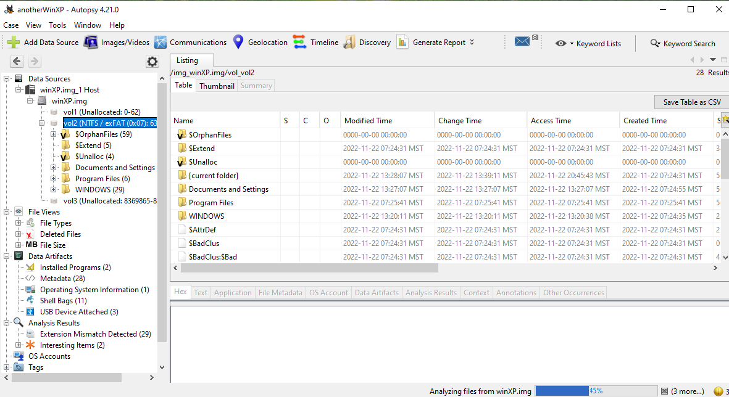

How does the image demonstrate that you completed the test?
The screenshot shows the information of the directories and folder files of the disk image loaded, which means the disk dump was loaded successfully.

Test 3: Identify the OS Information
Summary of test experience:
Now that the disk dump was loaded, the next phases were figuring out information about the disk. This test was to know the OS information.
Screenshot of test results:
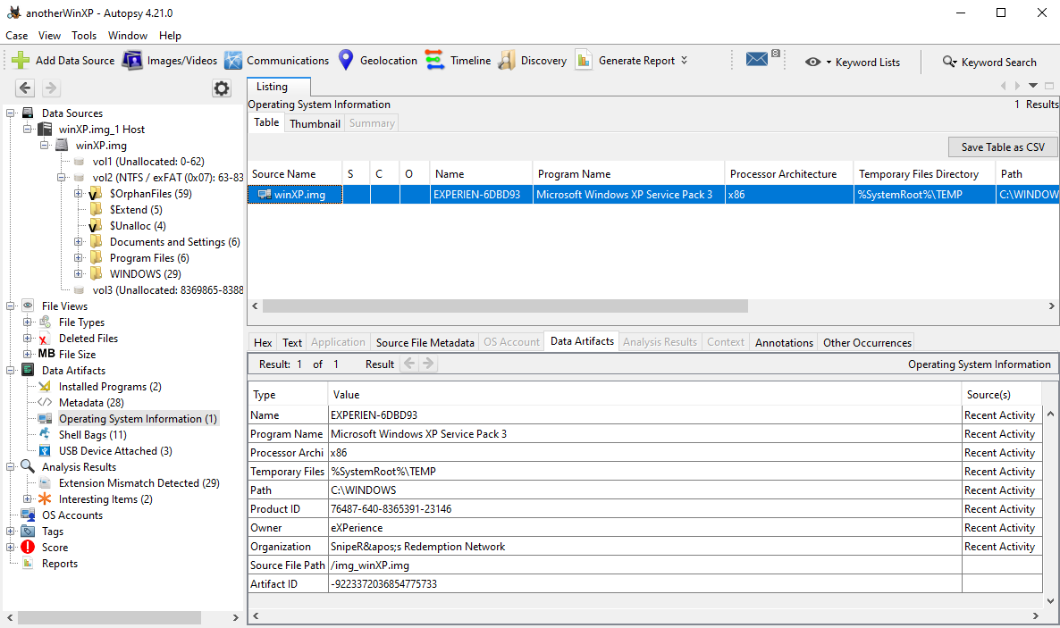
How does the image demonstrate that you completed the test?
The screenshot provided has the OS information of the windows image provided and loaded. The processor, metadata information, source of the root temporary files, and the structure of the image is shown.

Test 4: Identify the Ransomware Program
Summary of test experience:
At this point of the experiment, identifying the change because of the ransomware installed in the system. After downloading the ransomware given, the file directory was examined of the disk.
Screenshot of test results:
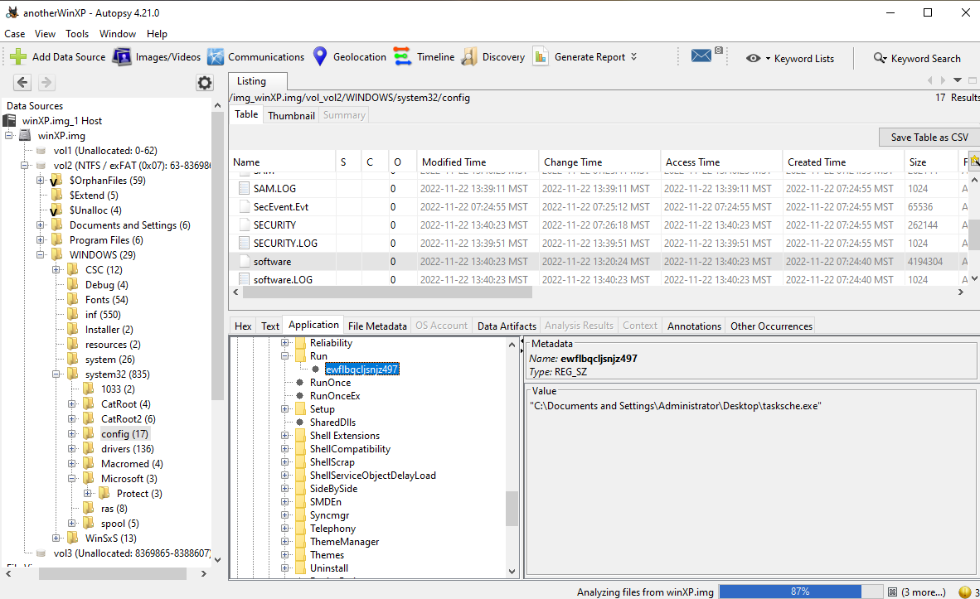

How does the image demonstrate that you completed the test?
The file shown in the directory in the currently running software, a task schedule, which is in the shown directory. This random name file is an indicator of the ransomware in the system.

Test 5: Get Details of the Ransomware Program
Summary of test experience:
Upon more investigation of the ransomware, this final test was to know the details of the ransomware from the SHA 256 hash from the investigation.
Screenshot of test results:
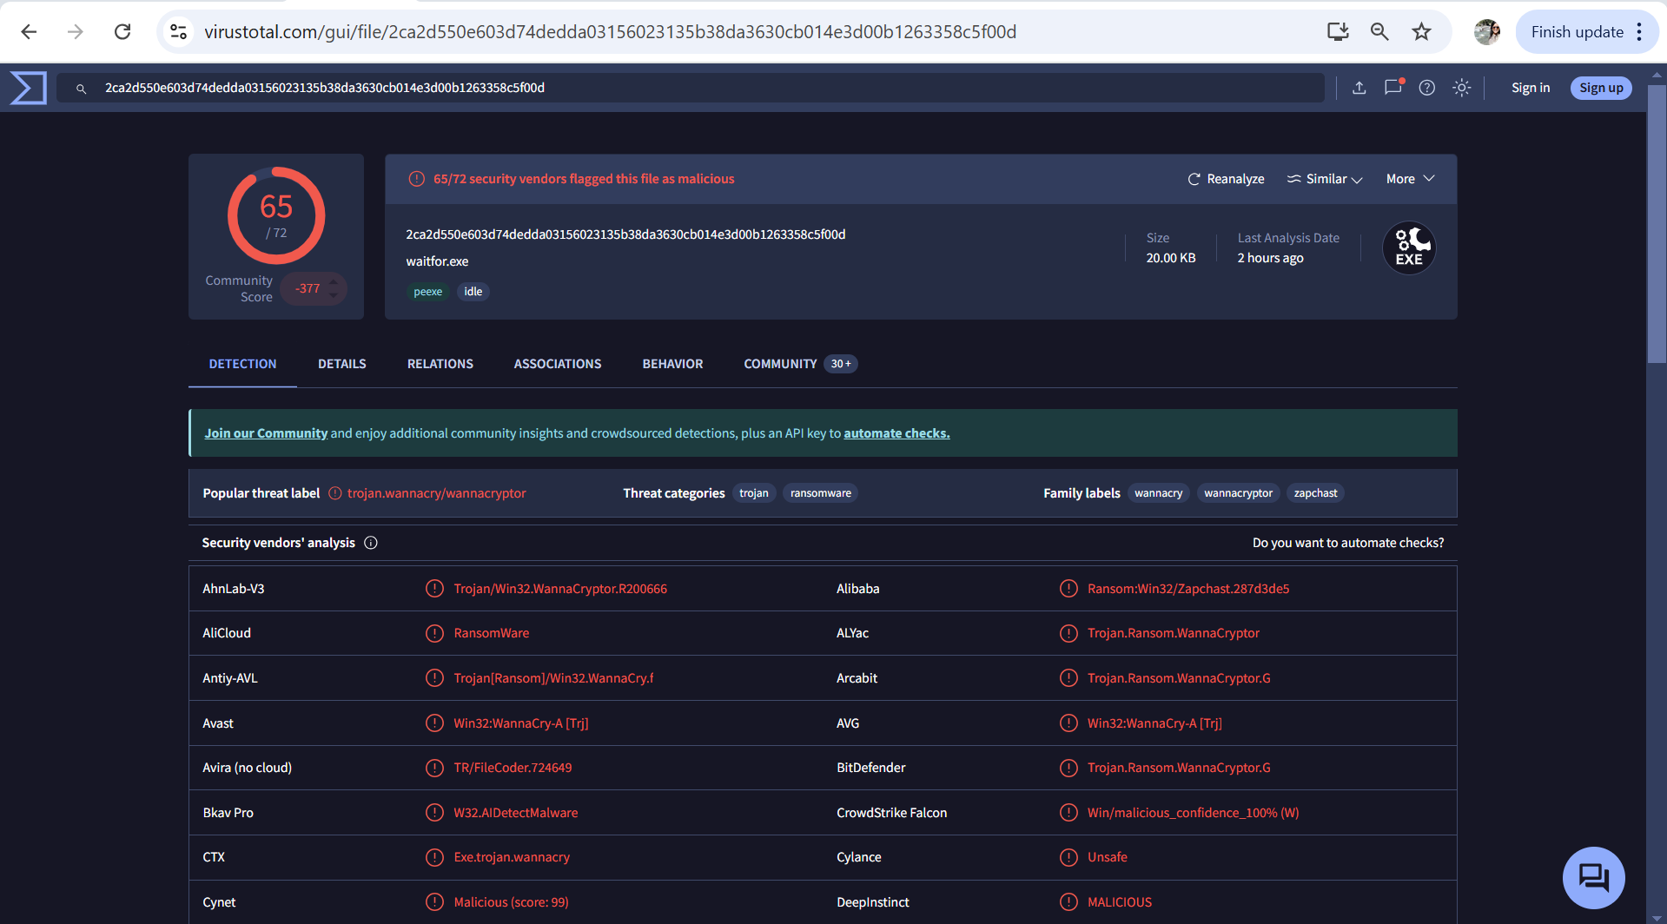
How does the image demonstrate that you completed the test?
The SHA 256 hash of the ransomware gave the above results when processed through VirusTotal, which showed the total malwares and all included in that ransomware.

